Using Architectural Reconfiguration to Improve the Extensibility of Component-Oriented Frameworks

Andrew McVeigh
Department of Computing
Imperial College
London, UK SW7 2BZ
+44 020 7594 8xxx
a.mcveigh@imperial.ac.uk
Jeff 1+2
Department of Computing
Imperial College
London, UK SW7 2BZ
+44 020 7594 8xxx
zzz@imperial.ac.uk

ABSTRACT
Frameworks are a reuse technique allowing a semi-complete application to be customized and extended into a complete application. This is an effective and large-scale form of reuse but in practice a number of fundamental issues limit the effectiveness of this approach. Many of these issues stem from architectural control and ownership of architectural changes.
In order to address these issues, the notion of a component redefinition construct is presented, allowing components in an architecture to be reconfigured via a set of changes. This allows the application developer the freedom to express changes to a component-oriented framework architecture, and still use the framework as is. The technique also allows framework architectures to be treated as composite components and vice versa. This brings advantages to both types of architecture.
Component redefinitions are also shown to have relevance to the frameworks at the heart of plugin architectures. In particular, the approach allows for more flexible customization of this type of system.
Finally, the limitations of the basic redefinition constructs are explored, leading the way to a discussion of more advanced constructs that will address the shortcomings.

Keywords
Frameworks, component-based architectures, plugin architectures, configuration specification, architectural reconfiguration, system evolution, component reuse, unplanned reuse, extensibility.

INTRODUCTION
Frameworks are a technique allowing a semi-complete application to be customized and extended into a complete application. This has proven to be a very effective form of reuse, although in practice a number of significant problems limit the effectiveness of this approach. Plugin architectures have frameworks as their defining architectural feature, and as a result the limitations of frameworks apply directly to this class of system also.
Many of the problems arise from the necessary division between application and framework developers, and the architectural control and ownership problems that follow from this. Further issues come from the inevitable pressures and conflicts that arise when a framework is reused for multiple applications.
We show how a component-oriented framework can be represented as a hierarchical component with placeholders [1] denoting pre-planned areas of extension. The architecture is explicitly separated from the computational elements using techniques derived from the configuration specification of distributed systems. A reconfiguration construct called component redefinition is introduced, allowing changes to a framework architecture to be expressed as deltas, maintained separately from the architecture. Component redefinition is designed to be as intuitive to work with as the component construct. The applicability of this construct is demonstrated by showing how it reduces or alleviates some of the framework reusability issues. It is also shown that redefinitions can allow any hierarchical component to be used as a framework, increasing the extensibility of component-based systems and allowing for a level of unplanned reuse.
This paper is organized as follows. Section 2 outlines the framework concept. Component-oriented frameworks are defined, and the notion of keeping the architectural structure separate from the computational elements via a configuration specification is discussed.
Section 3 discusses some of the barriers to greater reuse of frameworks. Section 4 introduces basic component redefinition, and examines how it addresses the reuse problems. The limitations of this construct are shown, and more advanced constructs are referred to which aim to avoid these limitations.
The paper ends by looking at related work on addressing framework limitations, and discusses future work and direction.

BACKGROUND
The component redefinition constructs presented in the paper require an understanding of frameworks and configuration specification approaches to architecture.

Informal Definition of the Framework Concept
A framework is informally defined as “a reusable, semi-complete application that can be specialized to produce custom applications” [2]. Frameworks offer an effective, large scale form of reuse because application developers need only provide implementations of the missing parts in order to reuse the architecture expressed by the framework. The framework codifies the solution to a particular problem or domain, and allows the application developer to express feature variance within pre-designed limits via extension points. In practice, frameworks may represent smaller problem domains than full applications, and several frameworks may be layered or integrated to produce an application.
Framework developers create the framework, and application developers reuse and extend the framework to produce an application. An important point is that the application developers and framework developers are (logically, at least) distinct groups with different concerns. This separation is usually enforced to avoid the temptation to push concepts from a single application directly into the framework as this limits reuse. The framework must satisfy many applications, and accommodation for a single application must usually be conceptually generalized to cover all applications, or expressed as an extension point.
application developer
framework developer
creates
creates
framework
extension
registration mechanism
Figure 1: Application developers extend the framework, but do not modify it directly
As noted in [3], a framework is an extensible class library that allows an application developer to insert implementation code directly into a pre-packaged library. The motivation is to increase the reusability of class libraries by increasing their extensibility.
Object oriented frameworks are implemented as a set of collaborating concrete classes, with extension points expressed through required interfaces. These extension points are sometimes referred to as “hooks” [4]. The application developer writes classes implementing the required interface(s) and registers concrete instances with the framework using a registration mechanism. Control is then handed over to the framework, and at the appropriate time the framework will call out to the extensions. This is known as “inversion of control” [5], as the framework controls the collaborations rather than the application. Much of the value of a framework architecture lies in the collaborations expressed between the concrete classes comprising the framework.
The figure below shows an example framework for a kettle. When the user presses a button on the kettle, it boils the water. It also updates a DisplayPanel to show what it is doing. The Alarm extension point is used to indicate to the user when the water has boiled. Although the components have a direct correlation to physical components, this is not a crucial part of this example.
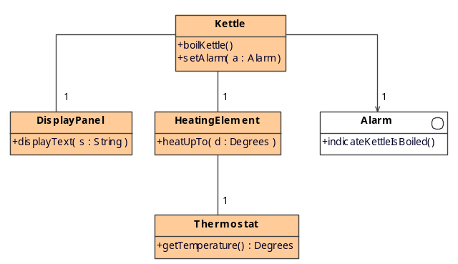
Figure 2: The kettle framework
Figure 3 shows the collaboration for boiling a kettle. When the button is pressed to boil the kettle (1), the kettle updates the display (2) and asks the heating element to heat up (3). The element polls the thermostat until it has reached the desired temperature (4). At this point, the kettle updates the display again (6) and calls out to the Alarm (7) to make a sound to the user that the kettle is boiled.
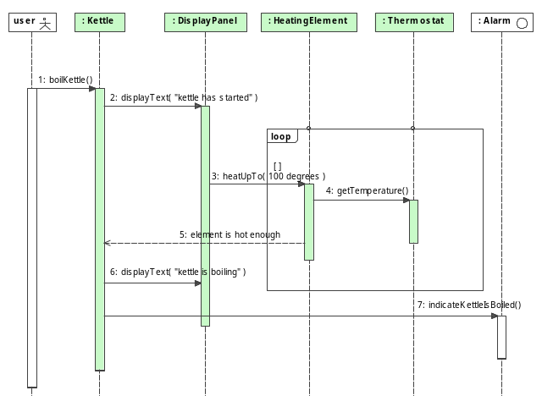
Figure 3: "boiling" collaboration
Note that the collaboration with Alarm is deeply buried within the control logic of the framework.
All the application developer needs to do to reuse the framework is to create a concrete implementation of Alarm and register it with the framework using the Kettle::setAlarm() method. One developer may use the framework with a musical alarm, whereas another may use the framework with a talking alarm. The same framework has been extended for multiple applications.

Minimum Framework Criteria
The following are deemed the minimum necessary criteria for any framework:
- A framework must encapsulate a solution to a given problem, through collaborations encoded within the concrete elements (classes or components) of the framework
- A framework must allow for extension, through one or more required interfaces
- The framework must provide a way for extension objects to be registered such that they can be connected to the unsatisfied required interfaces of the framework
- Each required interface should be used by at least one collaboration, so that the application developer’s extensions can participate in the behavior of the customized framework
The registration mechanism of point 3 can range from a programmatic way of storing an object reference with the framework, through to a registry mechanism allowing extensions to be stored against names.
An extension must minimally be joined up to at least one provided interface from the framework. In addition, it can be joined up to provided interfaces also, allowing the extension to invoke services provided by the framework.
Building on this definition, a plugin architecture is defined as a packaged application with a framework as its central architectural feature, allowing the loading of packaged extensions (plugins). All of the comments on frameworks in this paper, therefore, also apply to plugin architectures.
Frameworks are typically extended at implementation time rather than at runtime. Some advanced component systems have started to focus on runtime evolution via dynamic loading of extensions [6;7].

Configuration Specification of Component-Based Architectures
Configuration specifications have been widely used as a way of explicitly separating the architectural structure and properties of a system from its computational elements [8]. The specifications are programs, in an architecture description language (ADL), defining components and associated connectors.
Although this technique originated in research on distributed software systems, it can also yield benefits for systems with no distribution [9]. It is to the latter class of system that we direct our immediate attention, although we do not rule out applicability to the former situation. For non-distributed systems, components can be implemented directly using classes, and connectors can be implemented as direct object references.
Reconfigurations are delta changes in the architecture, which are maintained separately from the configuration itself [10]. The standard reconfiguration primitives are component and connector addition and removal, although this set must be expanded slightly for the UML2 component model as it includes ports also.
In section 4, the component redefinition construct is introduced. This is a way of specifying reconfigurations in an intuitive component-like form.

UML2 as an ADL
This paper uses a textual expression of the UML2 component model as the ADL. UML2 represents an evolution of the original UML notation [11]. One of the major changes has been the inclusion of ADL constructs into the language, which enables it to function as a configuration language.
A UML component may define a number of ports, expressing provided and required interfaces.
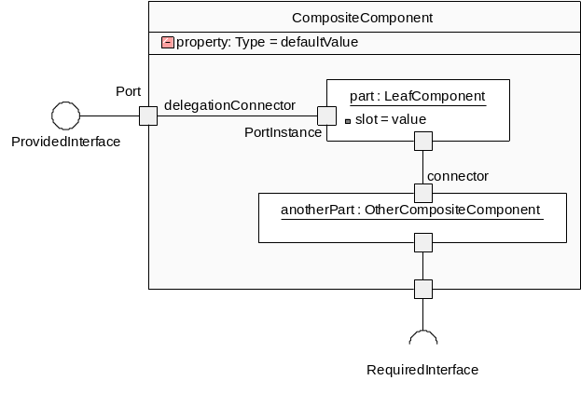
Figure 4: A UML2 composite structure diagram

Components may have properties, and parts have slots which map onto properties of the part type.
A composite component contains instances of other components, which are called parts. This leads to hierarchical component structures. Connectors represent a simple wire linking components and parts via their ports. As noted in [12], UML connectors are basic, but richer connectors can be represented explicitly as components.

Component-Oriented Frameworks
A component is a unit of software composition that explicitly declares its provided and required interfaces [13]. Composite components are composed of other component instances, leading to a hierarchical model which may be shown as a flattened graph with “contains” and “uses” relationhips [14].
A component-oriented framework uses components rather than classes to implement the framework. Extension points are represented through required interfaces, or by placeholders. A placeholder is a dummy component instance that exists in an architecture solely to indicate the minimal properties that replacement component instances must exhibit [1]. In component diagrams, placeholders are shown with a dotted outline. Note that replacement instances do not need to need to maintain a one-to-one mapping with placeholders, as long as the replacement instances together guarantee the minimum properties required.
The minimal component-oriented framework is a leaf component that provides a service and requires another. The code in the component needs to call out to the required interface, satisfying point 4 in the framework criteria.
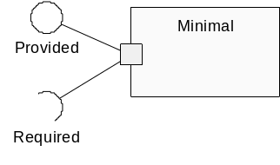
Figure 5: A minimal component framework
Figure 6 shows the kettle framework as a UML2 composite structure diagram. This shows provided and required interfaces, and connections between the ports of the component and the ports of the components instances (parts) making up the composite component.
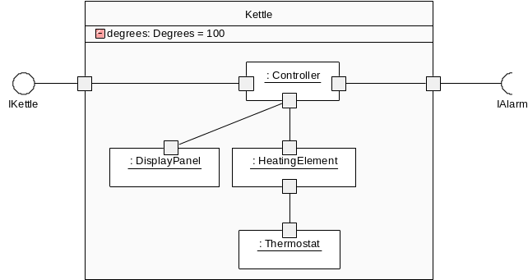

Figure 6: The kettle framework expressed as a composite component
The “degrees” property represents a parameterization of the framework. This can be configured by the application developer.
It is possible to use a placeholder instead, as depicted in Figure 7. This is the preferred approach, because it allows for deeply nested extensions to be shown without having to propagate the required interfaces to the component boundary.
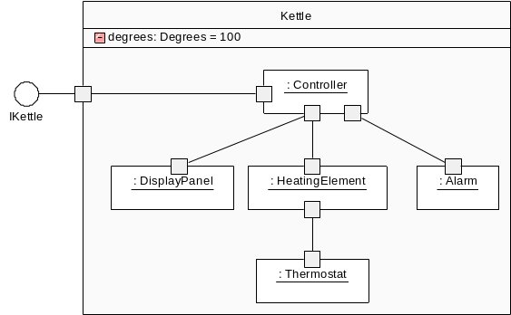

Figure 7: The kettle framework using a placeholder
Figure 8 shows the hierarchical model. Because connectors are located inside the context of a component, they cannot transgress levels in the hierarchy, and as a consequence the uses relationships also do not cross levels. This has important ramifications for the component redefinition construct, as it means that a reconfiguration which is bounded by the scope of a single component can make all relevant changes needed for that component.
Kettle
Controller
Display
Panel
Heating
Element
Thermostat
Alarm
Level 1
Level 2
Contains
Uses
Figure 8: A hierarchical model of the framework
Hierarchical models can go to any depth. Leaf components have no children, and map onto implementation components directly.
The collaboration patterns encoded within the Kettle framework can be represented as a state machine, as well as a sequence diagram. The invocation of the method on the required interface is shown in the exit point of the “boiling” state. Note that this state belongs to Kettle and the “heating” state belongs to HeatingElement, mirroring the structural composition.
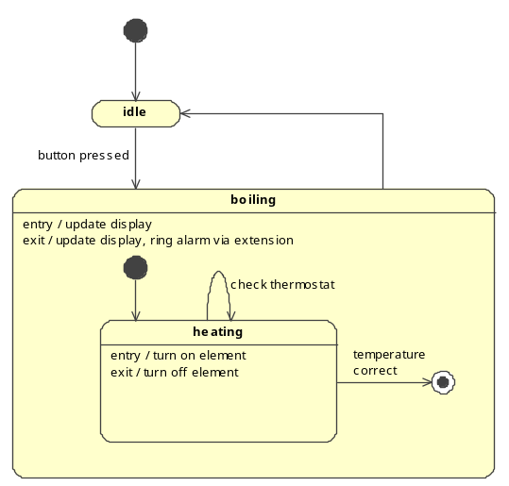
Figure 9: State machine for "boiling" collaboration, showing extension call

Backbone as a UML2-Based ADL
Backbone is a textual form a subset of the UML2 component model that has been developed to allow experimentation with component redefinitions. It is possible to express any UML2 composite structure diagram as a Backbone program.
stratum kettle;

composite-interface IKettle
{
}

component Kettle
{
properties:
degrees: Degrees(100);
ports:
mainPort provides IKettle;
parts:
controller: Controller;
panel: DisplayPanel;
element: HeatingElement
set limit(degrees);
thermo: Thermostat;
alarm: PlaceholderAlarm;

connections:
conn1 joins mainPort to controller.mainPort;
conn2 joins controller.display to panel.display;
conn3 joins controller.element to element.heating;
conn4 joins element.thermo to thermo.thermo;
conn5 joins controller.alarm to alarm.main;
}
Figure 10: The kettle framework in the Backbone ADL
Backbone contains a package-like construct called a stratum. A stratum contains component and interface definitions, and expresses explicit dependencies on other strata, allowing the architecture to be partitioned. A stratum can also contain component redefinitions, which are commands to modify the definitions of components in other strata. Because of this, it is necessary to indicate a strata loading order. In effect, a stratum can be viewed as a UML package which expresses dependencies on other packages and has a precise loading order relative to other packages in ambiguous situations.
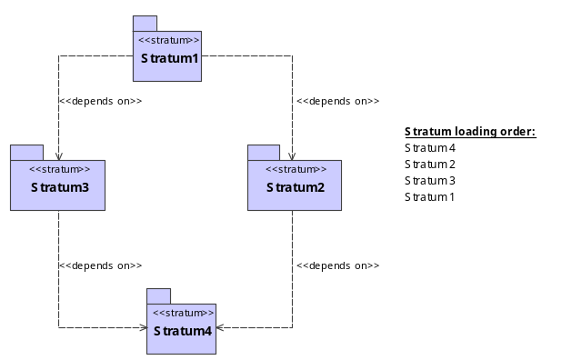
Figure 11: The explicit loading order resolves the ambiguity over Stratum2 and Stratum3

Some Problems Affecting Framework Reuse
Any factor that prevents the reuse a framework in an unchanged form, in a situation where it would otherwise be suitable is considered to be a reuse problem. In practice, a significant number of issues hinder the reuse of frameworks.
[15] contains an excellent discussion on many of these problems in the context of framework development. [2] outlines the weaknesses of frameworks from the perspective of reuse.

The ownership problem
As explained previously, the application developer is typically not the same person as the framework developer. When reusing a framework, the application developer must use the framework without modifications, and can only take advantage of the extension points provided.
Of course, if new extension points are required, the application developer can copy and fork the source code but this means that they are now responsible for the ongoing development and maintenance of their copy of the framework. This removes one of the main drivers for using a framework in the first place. The alternative is to feed requirements into the framework development process, and wait for the framework developer to generalize the application-specific requirement and add the concepts to the framework. This is usually impractical due to the time scales and loss of control for the application developer.
This problem exists in the kettle framework if an application needs to replace the DisplayPanel part. This is not possible in the framework as it stands, as it is not an extension point.

The application-specific requirement problem
Frameworks are used to build multiple applications, each with differing requirements. These applications impose requirements on the framework, which creates pressure for specific concepts of a single application to migrate down into the framework itself. Reuse is impeded if this happens because these concepts are only applicable to one application, and should be expressed at the application level instead. Allowing application developers control of the framework will lead directly to this situation. In this sense, this is the problem we get if the ownership problem is not addressed.
The obvious way to accommodate this type of pressure is to generalize the application-specific concept into a framework concept. However, this implies that the framework must be evolved, and this leads to the evolution problem.

The evolution problem
As a framework evolves, it may result in previous applications built using it to stop working correctly. The extension points may have changed, interfaces may have been altered, and the underlying collaboration patterns may have also adjusted. If many applications have been built on a framework it is very difficult to evolve it to meet new requirements because doing so will result in a large amount of migration and testing work.
Furthermore, it is usually not possible to detect beforehand whether preexisting extensions will work with a new version of a framework.
As pointed out in [16], reusable assets must be properly evolved. Evolution should not imply that previous applications built on the framework no longer work correctly. The other side of the issue is that reuse must involve using the framework as is, rather than copying the source code, as it is important for existing applications to get the benefits of the evolved and maintained framework. These forces are in tension, and often work to prevent framework evolution.

The buried extension point problem
Frameworks are often layered on top of other frameworks [17]. For instance, a framework for GUI forms entry will be layered on top of a windowing framework. When an application developer uses the upper framework, they are generally not able to extend or customize the lower framework because the upper framework has already used the extension points of the lower one. This creates a problem where lower-level abstractions are “buried” by higher level abstractions, creating inflexibility. This is a variant of the abstraction problem [18].
Lower framework
Upper framework
Application
Figure 12: The application cannot extend the lower framework, as the extension point has been buried

The integration problem
It is sometimes desirable to build applications that integrate two or more frameworks. This integration is motivated by the desire to combine the features of several frameworks into a single application. Each framework complicates this by effectively assuming that they have full control of the application. For instance, merging a form-based GUI framework with a terminal-based framework that is used for customer data entry will inevitably find that each framework has its own event dispatch loop. This is a problem even when integrating frameworks from completely different domains.

The unplanned extension problem
Feature analysis is usually used to determine the required variability of a framework, leading to a set of extension points. These points are fixed for a given framework. If an application developer wishes to add extension points, they must copy and modify the framework source code with the resulting drawbacks. This is also related to the ownership problem.

The multiple extensions problem
Plugin architectures, in particular, may end up hosting many extensions to a single framework. It is often the case that two or more independently developed extensions will be incompatible, because they will extend the framework at the heart of the plugin architecture in incompatible ways.

The base type problem
Frameworks express extension points in terms of minimal requirements on extension objects. In most cases, a framework will depend on base types, which the application developer will extend. This presents a problem when the framework passes an extension object back through a call on a required interface to another extension object. As shown by the following diagram, an application can pass in extension references into a framework, and receive them back again in the form of an instance of a base type. This requires the application to downcast to get the full type of the object again.
This problem makes it difficult to statically analyze the typing requirements to extend a framework.
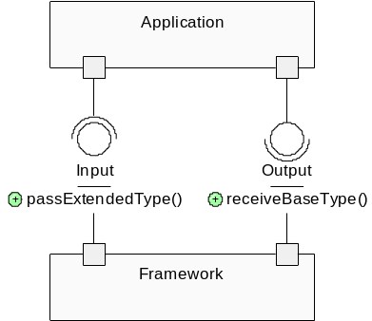

Figure 13: Extended types can be passed in, but will be sent back as a base type that the framework understands
For conventional components, this problem can be alleviated by the use of type constraints linking ports on the outer surface of the component [19]. As will be shown in the next section, however, component redefinition allows new extension points to be created, making this problem more obvious.

Component Redefinition
Component redefinition is a construct that allows a component to be reconfigured by the specification of a set of changes. The changes to the component are kept separate from the original definition, allowing changes to be made to the component even if the developer does not control the component definition. This will be explained by a working example, showing how to customize the kettle framework into an extended framework that includes extra extension points and an upgraded display.
Two variants of the component redefinition construct exist. “Existing component redefinition” allows changes to be made to an existing component. “Is-like component redefinition” allows a new component to be defined in terms of changes to an existing one.

Upgrading the Display Panel
Suppose that the application developer wished to use the kettle framework to build a family of kettles with upgraded displays. Currently, the framework has a concrete DisplayPanel. The application developer can use “existing component redefinition” to substitute the AdvancedDisplayPanel.
stratum advancedkettle depends-on kettle;

component AdvancedDisplayPanel
{
… (code omitted)
}

redefine-component kettle.Kettle
{
replace-parts:
panel: AdvancedDisplayPanel;
}
Figure 14: Redefining Kettle to use a new display
The replacement has worked via the name of the part. We have asked that the component be redefined to substitute a different type of display. Note that the existing connections will be connected to the new display. We have literally substituted the new panel for the old one. In effect, we have created an extension point where none existed previously.
This type of arbitrary replacement creates great problems in an object-oriented framework [3], but because we are dealing with a component-oriented framework the problems are far more tractable. In particular, each component specifies the services provided and the services required and conforms to a set of protocols. As long as we respect these protocols, we are free to exchange components.
Note that the original framework has not altered. The change to the framework will only be made if the “advancedkettle” stratum is included in the loading order of an application. The application developer controls the definition of this stratum, and has been able to make the change without the cooperation of the framework developer. This allows a far greater level of architectural control than previously offered in framework systems, and directly addresses the ownership problem.
In addition, it is now feasible for an application developer to directly insert application-specific components directly into the framework, addressing the application-specific requirement problem. The use of a redefinition does not limit the framework, while still allowing a very specific component to be substituted for a previously general one.
“Is-like component redefinition” is a variant that allows a new component to be specified by differences from a base component.
stratum advancedkettle2 depends-on kettle;

component AdvancedDisplayPanel
{
… (code omitted)
}

component AdvancedKettle is-like kettle.Kettle
{
replace-parts:
panel: AdvancedDisplayPanel;
}
Figure 15: Is-like component redefinition
This allows the application developer to reuse the architecture of Kettle, without perturbing the actual Kettle definition in any way.
The two variants of component redefinition serve different purposes. Is-like redefinition can be used to define a new component in terms of changes from an existing component, whereas existing component redefinition will redefine a component used in an existing architecture.
The redefinition construct allows for the deletion, addition and replacement, by name, of any port, part, property or connector of a component. The construct (and variants) presented above is known as “basic component redefinition” as it is not able to address a number of the framework reusability problems in its current form.

Introducing a New Extension Point
After upgrading the display, the application developer wishes to introduce an extension point to accommodate a number of different types of Thermostats. This can be achieved by switching out the Thermostat with a placeholder, effectively creating a new framework with an additional extension point.
stratum advancedkettle3 depends-on kettle;

component AdvancedDisplayPanel
{
… (code omitted)
}

redefine-component advancedkettle.AdvancedKettle
{
replace-parts:
thermostat: PlaceholderThermostat;
}
Figure 16: Adding an extension point to a framework
This has partially addressed the unplanned extension problem. We have created a point of variance where none existed before without disturbing the original framework.
Note that we have chosen to use is-like redefinition to create a new framework rather than disturb the original kettle component.

Adding a New Concept to the Framework
The developer now wishes to add a safety timer to the kettle, which turns off the element if it has been on for longer than 100 seconds. We need to redefine the HeatingElement component to add a new port via which we can tell the timer to start, and also poll it to see if the time has been exceeded.
Unfortunately, the element contains no current provision for a timer. Using basic redefinition, we cannot adjust the control logic of the existing HeatingElement component. Consequently, we must replace it to allow an added port to participate in the behavior of the component.
Now we can redefine Kettle to include the timer, and connect it to the element, as shown in in Figure 17.
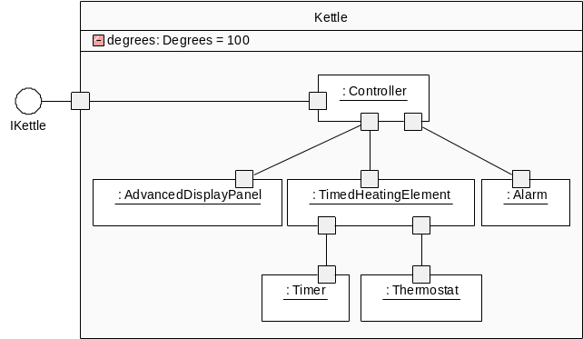
Figure 17: Kettle redefined to add a Timer concept
This example shows that additional concepts can be introduced by substituting relevant components with additional logic and structure, addressing a different facet of the unplanned extension problem.
Two points should be noted from this case:
- As the component structure becomes more fine grained, it becomes easier to substitute parts and evolve.
- Basic component redefinition only allows the structure of a component to be modified. The control logic can only be modified indirectly.
From point 1, we form the preliminary observation that structuring the architecture of a system in a fine grained fashion improves the extensibility, reuse and evolution of that architecture. Rather than replacing a large component, we are able to replace a part of that component to give the required effect. This directly relates the possibility of reuse to architectural detail. If Kettle was completely monolithic then the only possibility would have been to replace it completely. Because it was further divided into other parts, we were able to replace the part that was no longer appropriate, even if point 2 means that we have to replace more than we would like.
Point 2 indicates a limitation of basic component redefinition that will be addressed by more advanced constructs that can redefine collaborations as well as structure. Ideally we could have redefined the “heating” collaboration to involve the timer without replacing the HeatingElement component completely.

Uncovering a buried extension point
Consider that the Kettle framework is now used as part of a coffee machine framework. This new framework allows coffee machines to be constructed, and introduces an extension point for the type of filter used.
As shown in Figure 18, Kettle has been extended to form a MusicalKettle, embedding a musical alarm within the reused component.
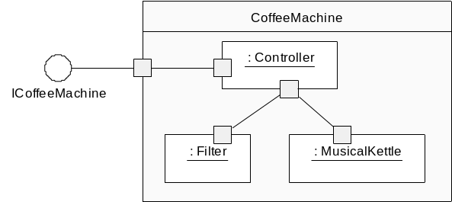
Figure 18: The coffee machine framework reuses the kettle framework
Suppose now, that an application developer wishes to build coffee machine with many different types of alarm. This extension point has not been exposed by the coffee machine framework as at design time it was not deemed necessary. Using component redefinition, we can reintroduce this buried extension point. Figure 19 shows one possibility, which is to redefine CoffeeMachine to use Kettle directly and propagate the require Alarm component up to the top level.
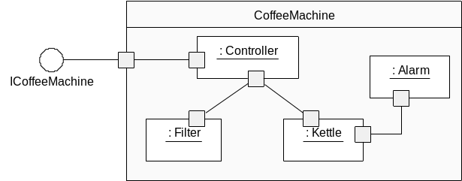
Figure 19: Redefining the coffee machine framework to reintroduce the buried Alarm extension point
As before, the coffee machine framework can be customized by a separate stratum which only the applications which want the new extension point will include in their loading order. No existing users of the framework need to be affected.

Evolving the framework
Redefinition addresses component evolution by allowing the evolution of the architecture to be expressed as changes which are kept separately from the original framework. In this way, we can evolve the framework whilst still leaving it unchanged for existing applications.
It is possible to structure the changes in two ways. In the first case, we can evolve the framework by creating a stratum that contains the evolutionary changes.
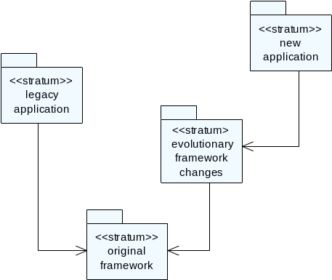
Figure 20: Evolving a framework through redefinitions
In the second case, we can push the evolutionary changes down into the framework, and use a legacy layer to redefine the framework to be suitable for the older applications.
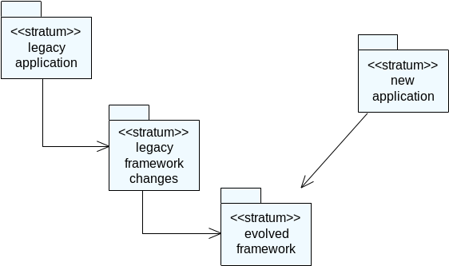
Figure 21: Preserving legacy structure of an evolved framework through redefinitions
In both cases, we are able to move the framework forward but preserve a level of backwards compatibility. The reuse of the framework has not constrained its evolution. Further, it is still possible to update the original framework, benefiting all applications that have reused it. In the second case, subject to some limitations discussed further below, it is possible to update and maintain the evolved framework and have the legacy applications selectively pick up the changes.
In this situation, it is important that we are able to combine redefinitions of the same component, as the legacy application may have redefined parts of the framework. In Figure 21 these redefinitions must still work correctly in the presence of further redefinitions in the legacy framework changes layer. As discussed later, the basic component redefinition construct cannot guarantee that this will be the case.
Note that the legacy framework changes and the evolutionary framework changes are the inverse of each other. In practice, we expect to be able to construct transformations which will automate the creation of one set of redefinitions from the other.

Integrating two frameworks
Consider that a tea machine framework also exists.
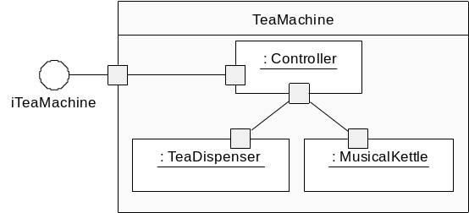
It is decided to create a combined tea and coffee machine which shares a single kettle. This requires integrating the coffee and tea machine frameworks to form a unified component.
Although this is possible with redefinitions, we end up replacing both controllers with a new TeaCoffeeController. This is undesirable, as we should ideally be able to merge the two controllers and reuse them directly. This is a limitation of the basic component redefinition construct. It offers no way to merge components and combine features from both without replacing any parts that require integration.

Limitations of Basic Component Redefinition
The main problem with basic redefinition is that it is not able to capture the intent of the architectural changes. As a consequence, it is not able to merge separate architectural deltas to the same component, and requires a stratum loading order to determine which change should have precedence. In many cases, the result of separate changes to a single component is an incoherent architecture which does not function as expected.
In order to address this issue, we need to arrive at a series of redefinition patterns which capture the intent of the architect. The compatibility of different patterns operating on the same component will be examined, and merging will take place according to predetermined rules which give a deterministic outcome.
In the case that two incompatible changes are specified, the architectural state of the system will be in error, and further constructs will be used to correct the problem. The aim is to arrive at a system where a stratum loading order is not required.
Redefinition can currently make only structural changes to a component. The aim is to also allow changes to the collaborations between components to be expressed. This will allow collaboration redefinition, leading to improved reuse of component parts. We believe this will also address the integration problem more directly. This type of redefinition will also need to address the multiple extension problem, as explained above.
By allowing any part of a component to be redefined, we increase the visibility of the base type problem. It is no longer enough to express type constraints only on the outer surface of the component [19]. We also need to express type constraints from the ports through to the parts. It may be possible to specify type constraints on outer ports, and automate the propagation of type constraints via delegation connectors and internal connectors, which will allow more powerful static analysis of composite Backbone components.
Finally, redefinition has little to say about the evolution of the behavior of the leaf components which are currently implemented in Java. It does not address the evolution of interfaces. For instance, an application developer may wish to evolve an interface to pass extra parameters.

Conclusions and Future work
Component redefinition is a powerful mechanism allowing for the principled redefinition of components. It allows components and frameworks to be treated interchangeably, and alleviates or ameliorates several of the framework reuse problems.
By allowing architectural changes to be kept separately from the component definition, the tension resulting from control of the framework is no longer a barrier to the reuse of the framework or the ongoing evolution of the reusable asset. Components become more extensible using this scheme, improving their reusability.
In essence, redefinition enables reuse by exploiting the architectural detail in the description of a system. The more fine grained the division of components and the more detail provided of the structure, behavior and intent, the more reusable the architecture becomes.
Future work involves building more powerful representations of the redefinition construct that can capture architectural intent precisely. The aim is to form a language where stratum loading order is not needed, addressing the multiple extensions problem and allowing the automated merging of architectural changes.
Collaboration redefinition will be added to the language, allowing collaboration protocols to be described and reconfigured. It is believed that this will greatly improve the ability to integrate frameworks.
It will also be useful to create a precise graphical representation for redefinitions and architectural changes. The intention is to allow the designer to work graphically with the changes, or to work with the expected system after redefinition. In the latter case, it is necessary to be able to reconstruct the changes and intent by examining the differences between the new and existing architectures.

Related Work
Some practical limitations of frameworks are examined in [15], [2] and [5]. [3] examines the problem of reusable class libraries and suggests protocol layering along with other approaches.
Contracts are proposed as a way of tracking and ensuring consistency of framework reuse in [20]. Reunification rules have been used to merge architectural changes in frameworks [21].
Balboa allows type constraints to be specified for component ports, and uses type inference to determine unknown types [19]. This addresses the base type problem for non-reconfigurable components.
Reconfiguration of an architecture is discussed in [8;10], as a way of adjusting the configuration of a system at runtime. [22] discusses structural refinement of UML2 components as a form of structural inheritance, as well as behavioral refinement of statecharts. Refinement in this context is strictly additive, preserving the subtype relation between components.
Various systems allow for architectural evolution to be tracked and analyzed [23;24]. Part of the aim is to analyze the evolution of an architecture, reconstructing the intent of changes.
Reuse operators have been proposed as a way to combine conflicting changes to a framework [15].
[25] establishes a preliminary UML notation for showing reconfigurations that add components to an architecture.

ACKNOWLEDGMENTS

There is significant overlap between composite structure and component diagrams in UML2. Composite structure diagrams are used, although component diagrams could also represent these concepts.
This notation is an extension as UML2 has no concept of placeholders.

